General Requirements

- Logos will be measured on a flat surface when the athlete is not wearing the uniform. The “FISO Logo Measurement Template” will be used to measure the logo sizes
- There is no restriction on the type of logo used in the sponsor spaces other than those representing tobacco, spirits and products containing any substance on the WADA Prohibited List. (See Diagram 1 for location of sponsor spaces);
- There minimum clearance around all marks shall be 12 mm, including:
  - The FISO logo
  - The family name
  - The country code
  - All sponsor spaces

Uniform Colour and Design

- Uniforms may be of any colour, preferably a solid, for ease of identification by race announcers, officials and media
- The uniform and podium apparel must be approved by FISO in advance
- Uniform design and materials should not adversely affect race performance, safety of function
- Sleeveless vests and two piece (top and bottom) uniforms are allow

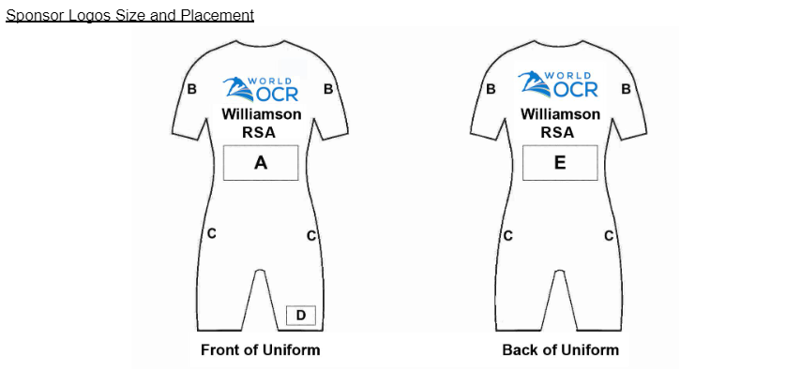
Family Name and Country Code

- The three letter country code (Country) must be centred on the upper front of the uniform and on the buttocks
- The initial of the first name may be added before the Name
- Presentation of the Name and Country must meet the following criteria

Lettering

The font type must be “Arial”
- Letters for the Name and Country must be in upper case, unless the name is more than 9 letters, in which case lower case letters should be used following the first capital letter
- Symbols such as ‘ - . and spaces are considered as characters
- The width for the Country must be between 50 mm and 175 mm wide
- For Names such as “MAY” the height is 50 mm and the width is 100 mm
- For longer Names such as “Williamson” the height is still a minimum 50 mm but the name should take up the full 150 mm

M A Y B. JONES Williamson
CHN SUI RSA

- Colour If the uniform is a dark colour, the letters must be white
- If the uniform is a light colour, the letters must be black

Position

- Front
  - The position on the front is below the FISO logo and Sponsor Spaces B and F
  - The athlete’s Name is above the country code and sponsor space A
- Back
  - The position on the back is below the FISO logo and Sponsor Spaces B and F
  - The athlete’s Name is centred above the country code
- Height
  - The Name and the country code must be 50 mm in height
- Width
  - The length for the Name is a minimum of 100 mm and a maximum of 150 mm
  - A Name with few letters must still be a minimum length of 100 mm

FISO Logo

The official FISO logo shall be placed:
- On the (athletes) left lapel, position F
- Front and back, centred and above all other logos

Sponsor Spaces

- Sponsor Space A, Front.
  - This space is directly below the State letters
  - Maximum height 200 mm
  - Maximum width 150 mm
  - Maximum of 3 logos
  - Each logo must represent a different sponsor.
- Sponsor Space B, Shoulders:
  - Maximum height 30 mm
  - Maximum length 50 mm
  - The space must be on the left shoulder of the uniform – not the middle.
- Sponsor Spaces C, Side panels:
  - The maximum width 50 mm
  - The maximum height 150 mm
  - Only one sponsor logo is allowed on each side
  - The logo must be visible from the side of the body. If, due to the athlete body shape, the logo is partly visible from the front, it must also be partly visible from the back.
- Sponsor Space D, Upper Leg:
  - Maximum height 30 mm
  - Maximum width 50 mm
  - The logo can be on the left or right leg, not both
- Sponsor Space E, Back:
  - One logo may appear below the Name
  - Maximum height 100 mm
  - Maximum width 150 mm
- Sponsor Space F, Upper Front:
  - One logo may appear above Name
  - Maximum height 50 mm
  - Maximum width 150 mm

